## **Data workflow automation using Tableau Hyper API – Part 2 (Delete, Insert)**

# Since we have already understood about HyperAPI in part one, will not discuss this again in part 2

# Update and publishing Tableau Hyper extracts with Python

**Let’s Set the Stage:**

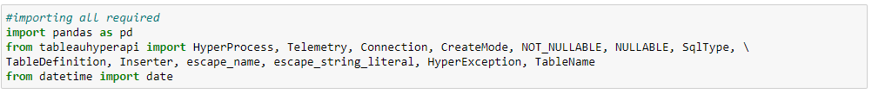



Now this time will load only those records where values changed or new records came in



Note: I have created one Column Syncoperation that will help me find the scenarios which existing record got changed or new record came in source

Input File Result in datafram.

I have made changes in quantity for existing orders also added one more row id 9995 & 9996.

Image Part1

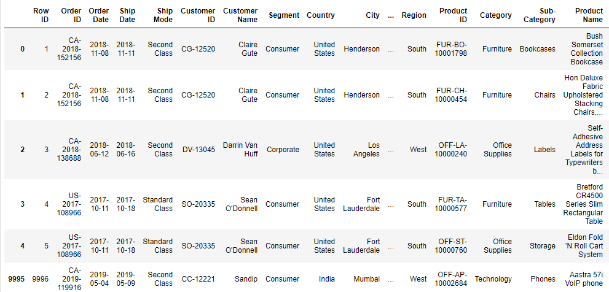

Image Part2:

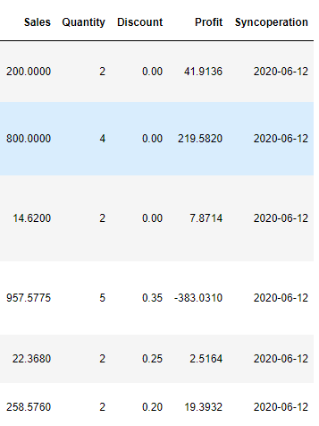

Sample of my input excel file

Let’s Start Hyper Engine

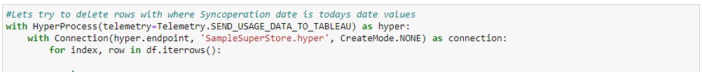

Now will loop for all the records which received in datafram for deletion from existing SampleSuperStore.hyper file

Operation for deletion will go something like this.

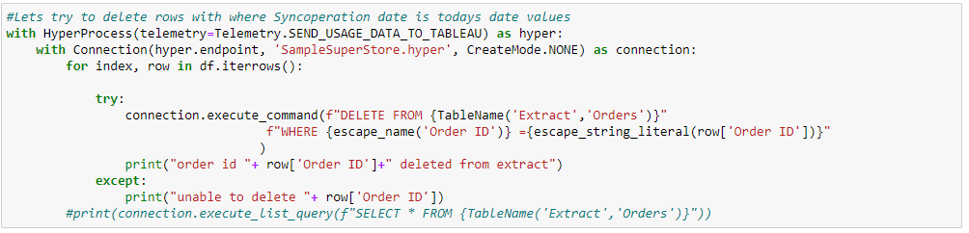

Run above statement you must get something like below result

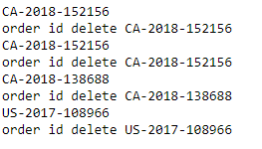

Now we have deleted records from hyper file for existing one. Next step will be to load all deleted and newly received records in datafram.

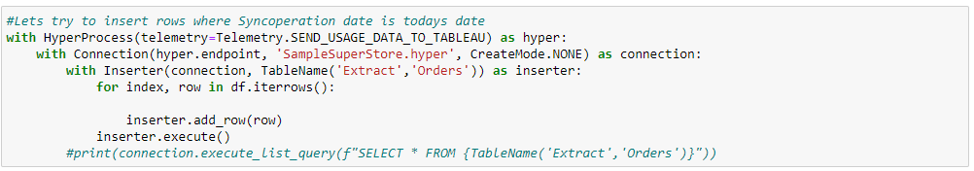

We have again inserted all the updated and newly received orders in our hyper file. Our next step should be to make this available for all the workbook so please publish the extract to your server file.

Note: Here we have not refreshed all extract again only upsert formed hence it will take few seconds to complete the operation which will save your time and server usage.

Will not discuss how to publish the same as we have already understood in part 1.

**Thank you so much!**